MYSQL VIEWS
Practical Examples and Student Exercises using MySQL Workbench

1.What is a View?
A View is a virtual table created from one or more existing tables.
- It does not store data itself.
- It stores only the SQL query.
- Whenever you query the view, MySQL retrieves the latest data from the underlying tables.

2. Setup: Employees and Departments Tables
Run this setup first. If these tables already exist with data, you may skip the setup.

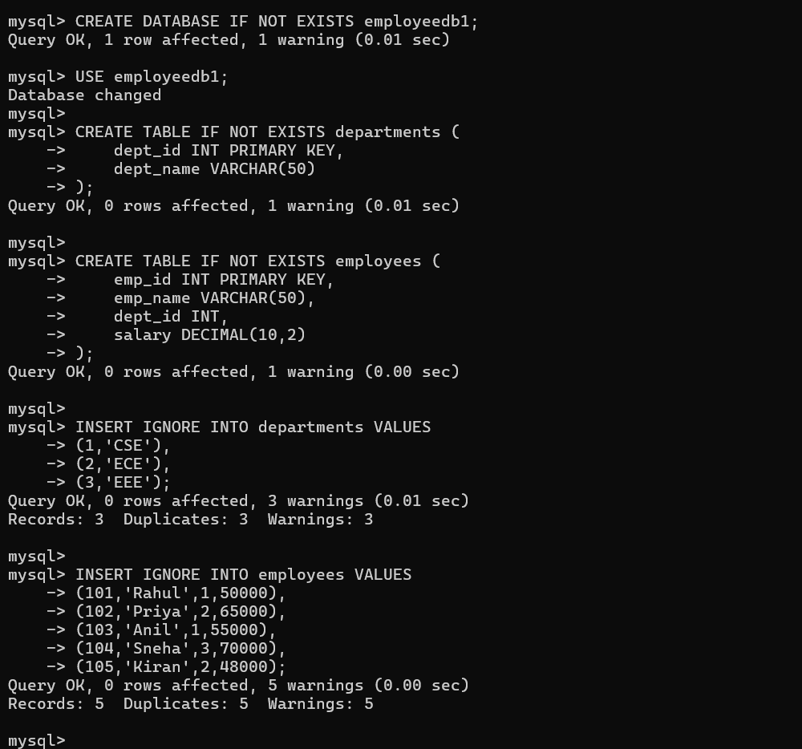3. Verify the Tables

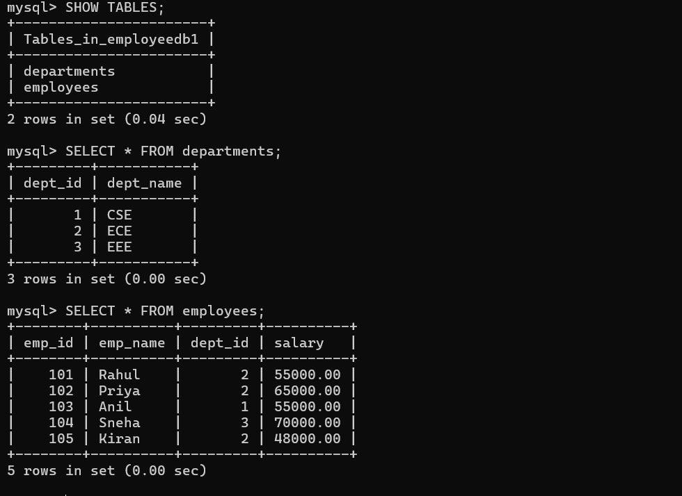View 1 – Display All Employees
Question: Create a View named EmployeeView to display all columns from employees.

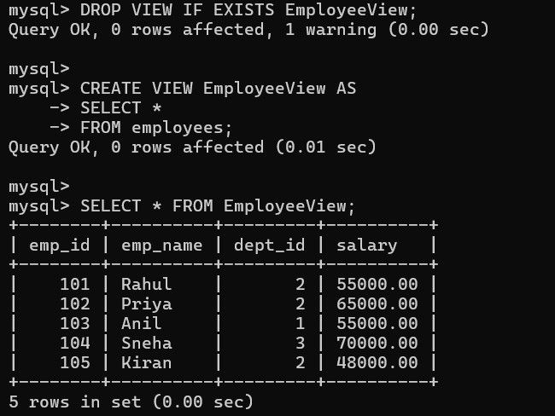View 2 – Selected Columns
Question: Create a View showing employee ID, employee name and salary only.

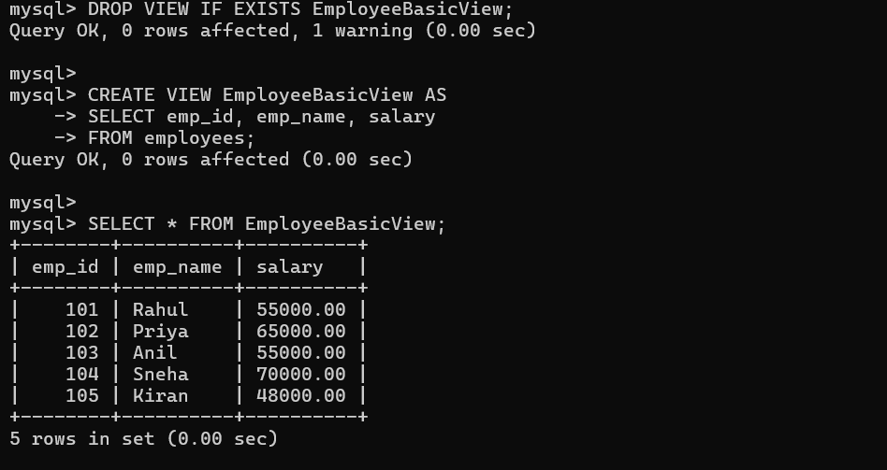View 3 – High Salary Employees
Question: Create a View that displays employees earning more than 55000.

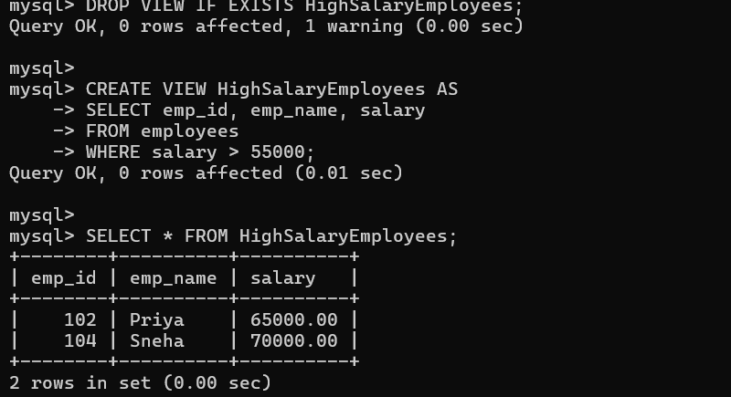View 4 – Employee and Department using JOIN
Question: Create a View that displays employee name, department name and salary.

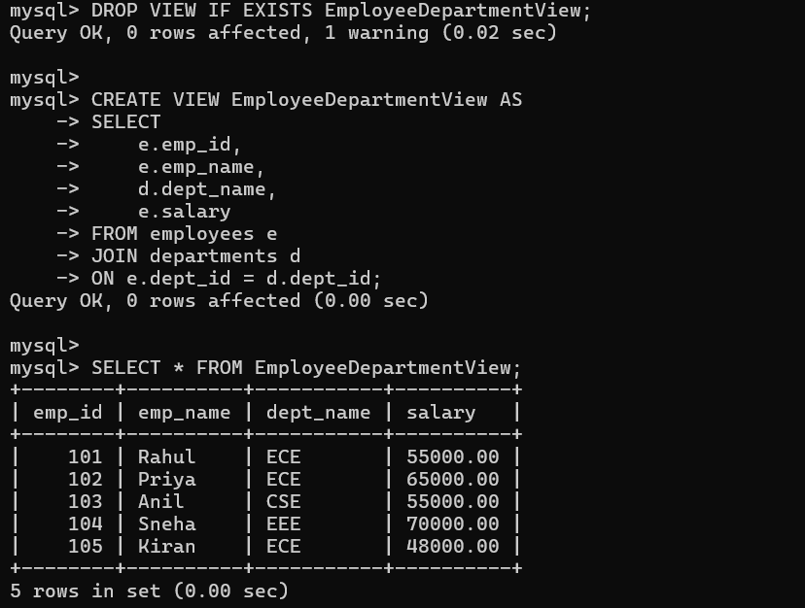View 5 – Employees from a Particular Department
Question: Create a View that displays only CSE employees.

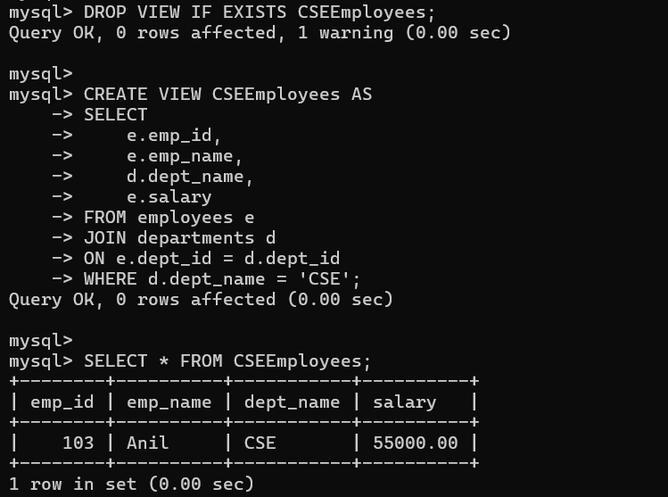View 6 – Department-wise Average Salary
Question: Create a View using GROUP BY and AVG() to display department-wise average salary.
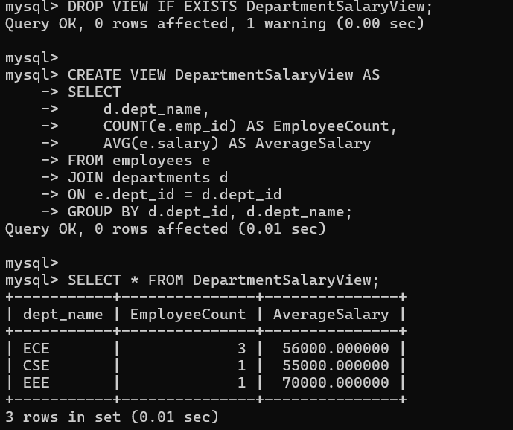

View 7 – Departments with Average Salary Above 55000
Question: Create a View that displays departments whose average salary is greater than 55000.

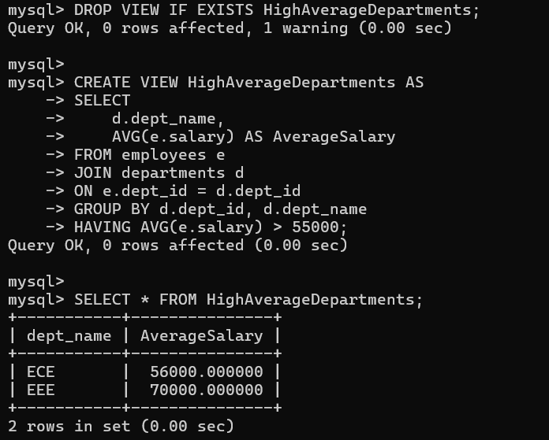View 8 – Salary Range View
Question: Create a View that displays employees with salary between 50000 and 70000.

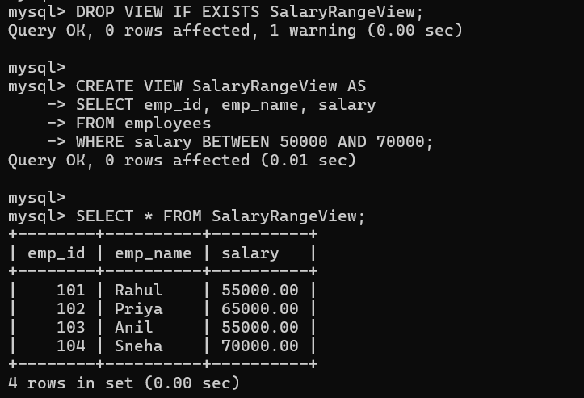View 9 – View with Calculated Column
Question: Create a View that displays employee name, monthly salary and annual salary.

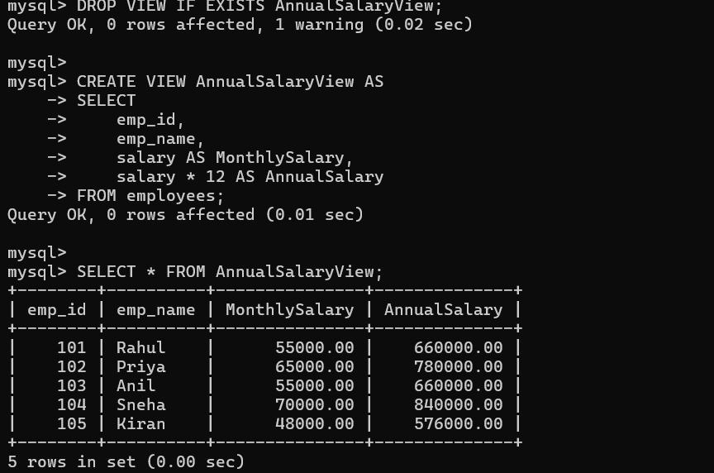View 10 – Update Data Through a Simple View
Question: Create a simple single-table View and update an employee's salary through the View.

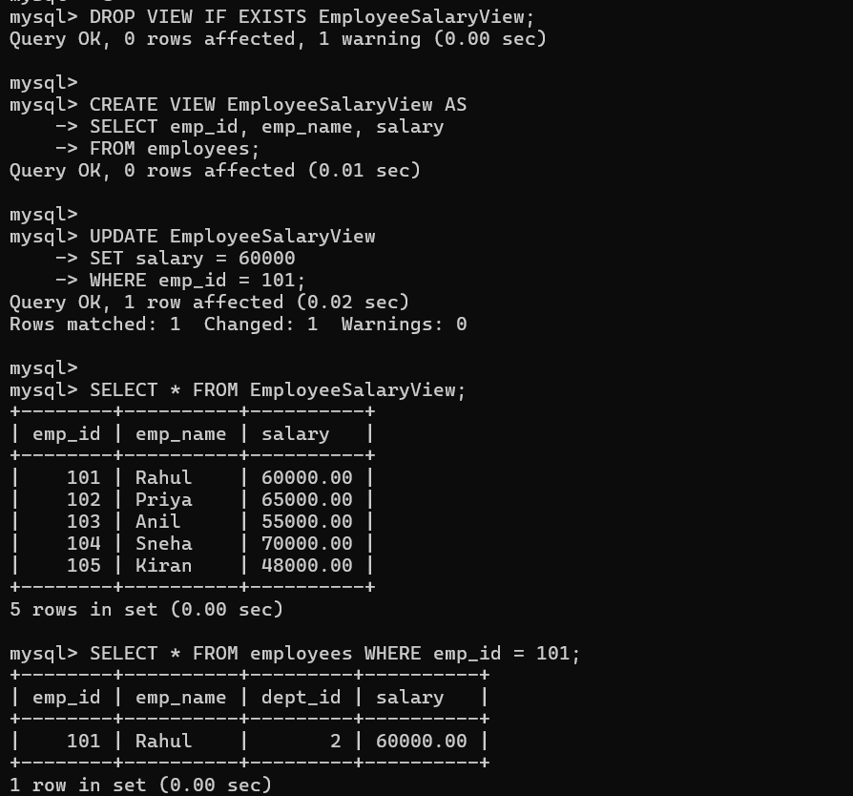View 11 – CREATE OR REPLACE VIEW
Question: Modify an existing View so that it displays employee name and salary only.

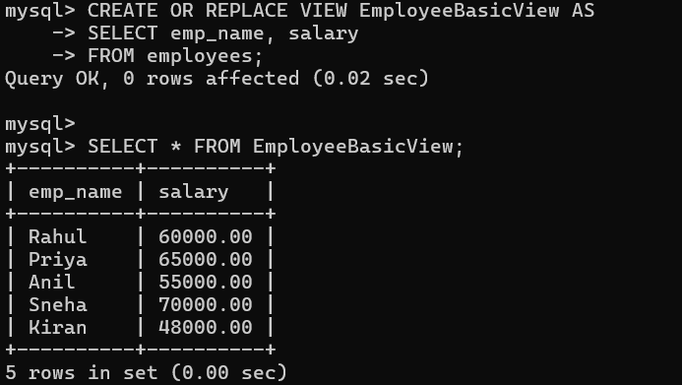View 12 – View Definition
Question: Display the SQL statement used to create a View.

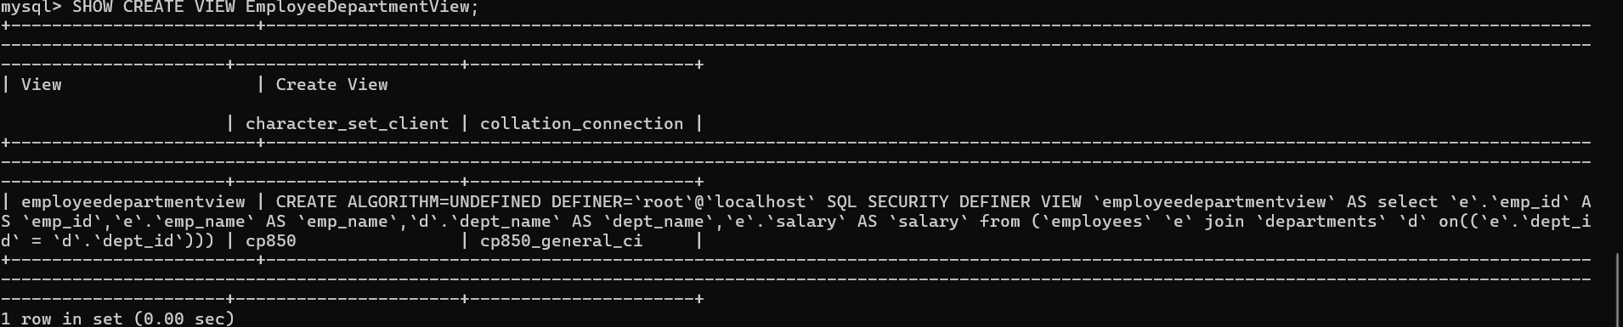View 13 – List All Views
Question: Display all Views available in the current database.
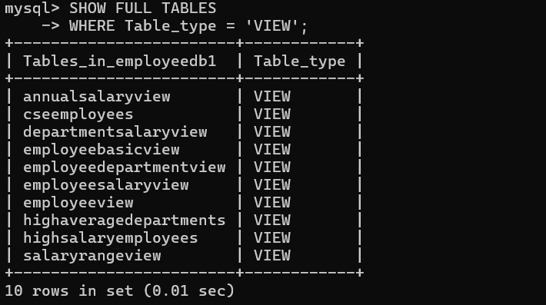

View 14 – Drop a View
Question: Remove an existing View from the database.

4. Important Concept: Simple View vs Complex View
A simple View is generally based on one table and does not use grouping or aggregate functions. Some simple Views can be updated. A View containing JOINs, GROUP BY, aggregate functions such as AVG(), DISTINCT, or other non-updatable constructs may not be directly updatable.

5. View vs Table
Feature | Table | View
Stores data | Yes | Normally no; stores query definition
Created with CREATE TABLE | Yes | No
Created with CREATE VIEW | No | Yes
Can use JOINs | Not applicable | Yes
Reflects current underlying data | Own stored data | Yes
Can always be updated | Yes | No; depends on the View

6. Student Practice Tasks
1. Create a View showing only emp_id, emp_name and salary.
2. Create a View for employees earning more than 60000.
3. Create a View showing employee name, department name and salary using JOIN.
4. Create a View showing only ECE employees.
5. Create a View showing department-wise employee count.
6. Create a View showing department-wise maximum salary.
7. Create a View showing departments whose average salary is greater than 50000.
8. Create a View with employee name, salary and annual salary.
9. Update an employee's salary through a simple View and verify the base table.
10. Use SHOW CREATE VIEW to display the definition of a View.
11. List all Views in the database.
12. Drop a View and verify that it no longer appears in the list.

7. Viva / Discussion Questions
1. What is a View?
2. Why do we use Views?
3. Does a View normally store a separate copy of the data?
4. What is the difference between a View and a table?
5. Can a View be created using multiple tables?
6. Can every View be updated?
7. Why are Views useful for security?
8. What is the difference between CREATE VIEW and CREATE OR REPLACE VIEW?
9. How do you display the definition of a View in MySQL?
10. How do you remove a View?

8. Common Errors and Solutions
Table does not exist: Run USE employeedb1; and check with SHOW TABLES;.
View already exists: Use DROP VIEW IF EXISTS view_name; or CREATE OR REPLACE VIEW.
Unknown column: Check the column names using DESCRIBE employees; or DESCRIBE departments;.
Cannot update View: The View may contain JOIN, GROUP BY, aggregate functions or another non-updatable construct.
Wrong database: Check the selected schema and run SELECT DATABASE();.

9. Quick Reference
CREATE VIEW view_name AS
SELECT ...;
SELECT * FROM view_name;
CREATE OR REPLACE VIEW view_name AS
SELECT ...;
SHOW CREATE VIEW view_name;
SHOW FULL TABLES
WHERE Table_type='VIEW';
DROP VIEW IF EXISTS view_name;

